Assignment No.04

Data Communication and Computer Networks

Assignment Date: Monday, 29,2023

**Name: Maaz Habib**

**Registration number: 20pwcse1952**

**Section: C**

Introduction to LAN

Task 1

Introducing LAN Topologies

Answer the questions below

1. What does LAN stand for?

**Answer:**

**local area network**

1. What is the verb given to the job that Routers perform?

**Answer**

**routing**

1. What device is used to centrally connect multiple devices on the local network and transmit data to the correct location?

**Answer**

**Switch**

1. What topology is cost-efficient to set up?

**Answer**

**Bus topology**

1. What topology is expensive to set up and maintain?

**Answer**

**star topology**

vi. Complete the interactive lab attached to this task. What is the flag given at the end?

**Answer**

**THM{TOPOLOGY_FLAWS}**

**Screen shot:**

Task 2

A Primer on Subnetting

Answer the questions below

1. What is the technical term for dividing a network up into smaller pieces?

**Answer**

**Subnetting**

1. How many bits are in a subnet mask?

**Answer**

**32**

1. What is the range of a section (octet) of a subnet mask?

**Answer**

**0-255**

1. What address is used to identify the start of a network?

**Answer**

**network address**

1. What address is used to identify devices within a network?

**Answer**

**Host address**

1. What is the name used to identify the device responsible for sending data to another network?

**Answer**

**Default Gateway**

**Screen shot:**

Task 3

The ARP Protocol

Answer the questions below

vii. What does ARP stand for?

**Answer**

**Address Resolution Protocol**

viii. What category of ARP Packet asks a device whether or not it has a specific IP

address?

**Answer**

**Request**

ix. What address is used as a physical identifier for a device on a network?

**Answer**

**Mac address**

x. What address is used as a logical identifier for a device on a network?

**Answer**

**Ip address**

**Screen shot:**

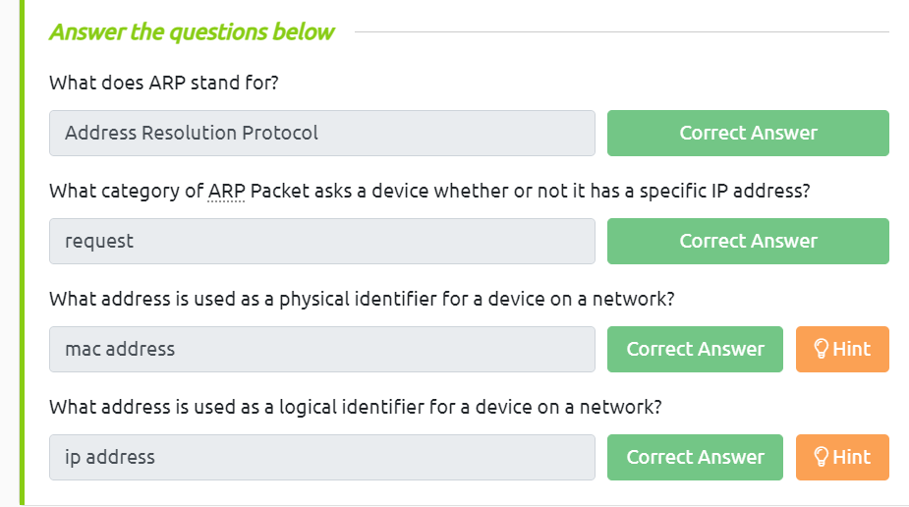

Task 4

The DHCP Protocol

Answer the questions below

xi. What type of DHCP packet is used by a device to retrieve an IP address?

**Answer**

**DHCP Discover**

1. What type of DHCP packet does a device send once it has been offered an IP address by the DHCP server?

**Answer**

**DHCP Request**

1. Finally, what is the last DHCP packet that is sent to a device from a DHCP server?

**Answer  
DHCP ACK**

**Screen shot:**

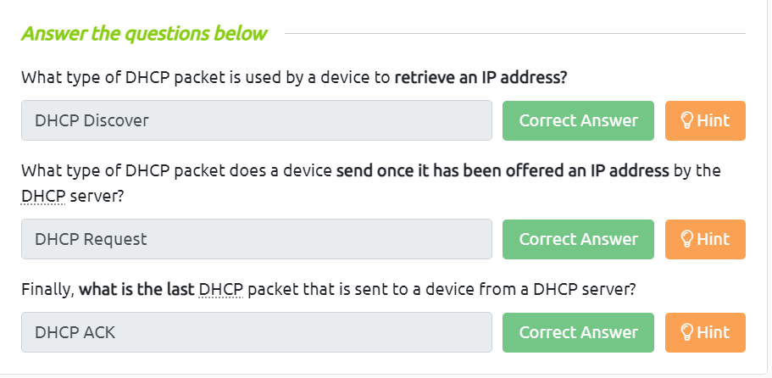

**Complete:**

